**Library Management System**

**1.Project Overview:-**

Library Management System is console-Based Application project. Various technologies we are used like Java(core),MySQL(Database),JDBC(Java Database Connectivity).

**2.Objective:-**

To develop a console-based Library Management System that automates the management of books, users, and issuing/returning books.

**3.Key Modules:-**

---**Main.java:**

Entry point of the application. Displays main menu for Admin and User access.

**---Admin.java:**

functionalities for the admin such as:

-Adding new books

-Viewing book list

-Deleting books

- Viewing issued books

**---User.java:**

Handles user-side operations:

-Viewing available books

- Issuing a book

-Returning a book

**---Book.java:**

Acts as the book model. Stores details like title, author, and quantity.

IssueReturn.java:

Contains logic for issuing and returning books and updates the database accordingly.

DBConnection.java:

Establishes and manages the connection between Java application and MySQL database.

**4. Database Schema:-**

books (id, title, author, quantity)

users (id, name, email)

issued_books (id, book_id, user_id, issue_date, return_date)

**5. Functional Features:-**

- Admin login with book management

- User access to issue and return books

- Real-time database updates

- Clean console menu interface

**6. Benefits:-**

- Automates manual library tasks

- Reduces human error

- Easy to maintain and extend

**7. Future Scope:-**

- Add GUI using JavaFX or Swing

- Email notifications

- Fines for overdue books

- User authentication and password management

**8.Output:-**

**Data store:-**

**Admin Data-**

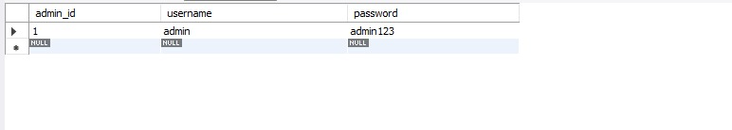

**User data-**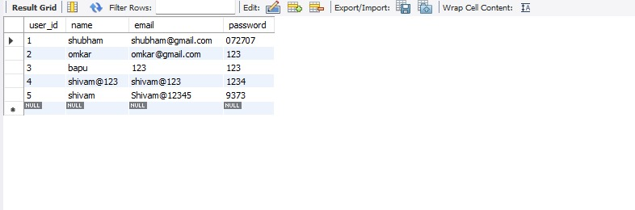

**Code:-**

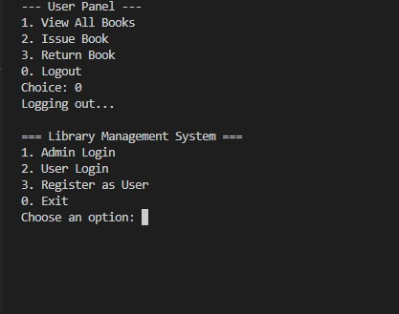

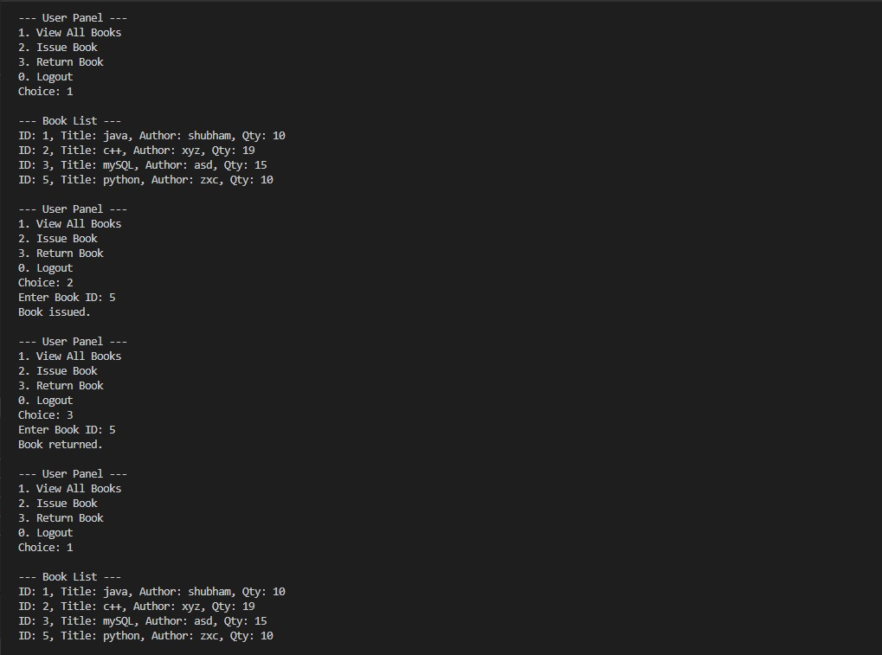

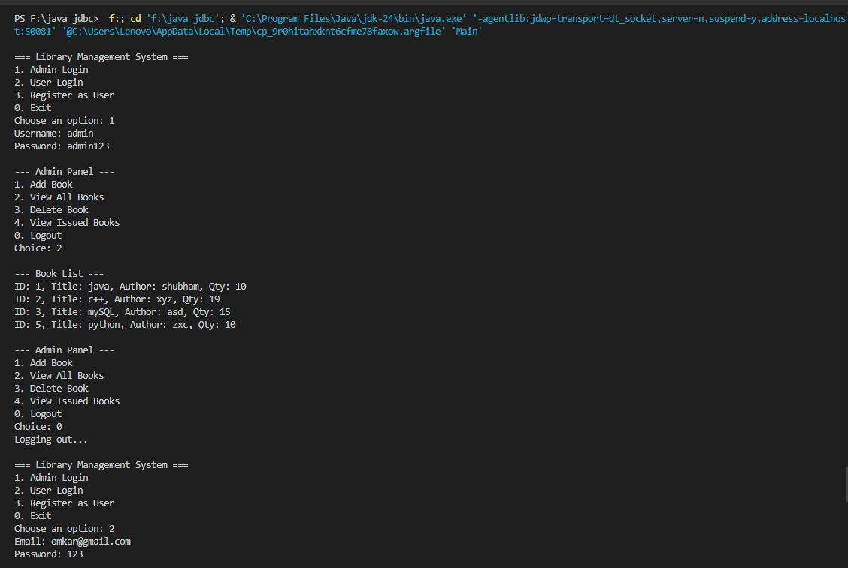

**9. Conclusion:-**

This Library Management System demonstrates the integration of Java and MySQL to solve real-world problems in library operations. It’s a scalable and efficient solution for small libraries.